** Welcome@Mars**

# Introduction

## Power Apps

Power Apps is part of the Microsoft Power Platform & O365 suite.

 

It enables to build apps fast with a point-and-click approach to app design. Choose from a large selection of templates or start from a blank canvas. Easily connect your app to data and use Excel-like expressions to easily add logic. Power Apps can be linked with wide range of back-end sources. Like SharePoint, Common Data Services, SQL etc.

Apps can be published to the web, iOS, Android, and Windows 10.

## Welcome@Mars

There about 500 locations around the globe at Mars. On each site, a visitor needs to sign in with paper and pen, and the process of connecting them with the people they were visiting is cumbersome and lacks any unified analytics.

Welcome@Mars comes with three set of applications –

1. Welcome@Mars Registration App
2. Welcome@Mars Pre-Registration App
3. Welcome@Mars Admin App

With the revised Apps built in Microsoft Power Apps, MARS is upgrading the experience of visiting its facilities while gathering a wealth of data that can be used to better manage facilities, reduce travel costs, and improve physical security.

1. **Welcome@Mars Registration App**

Registration App will enable visitor registration, picture capture as per each site’s configurations and will reduce manual work of front desk personnel by notifying the host they are meeting directly.

This app can be used by Mars Associates, Mars Contractors and External Visitors. On arrival, all visitors will provide their email ID, which the app verifies through Microsoft Azure Active Directory (Azure AD).

Post that visitors need to enter their details & selects host and sign a non-disclosure agreement form to complete the check-in process. In addition to this, external visitors need capture their picture based on their visiting site configurations.

Visitors will be entering their email address on their arrival -

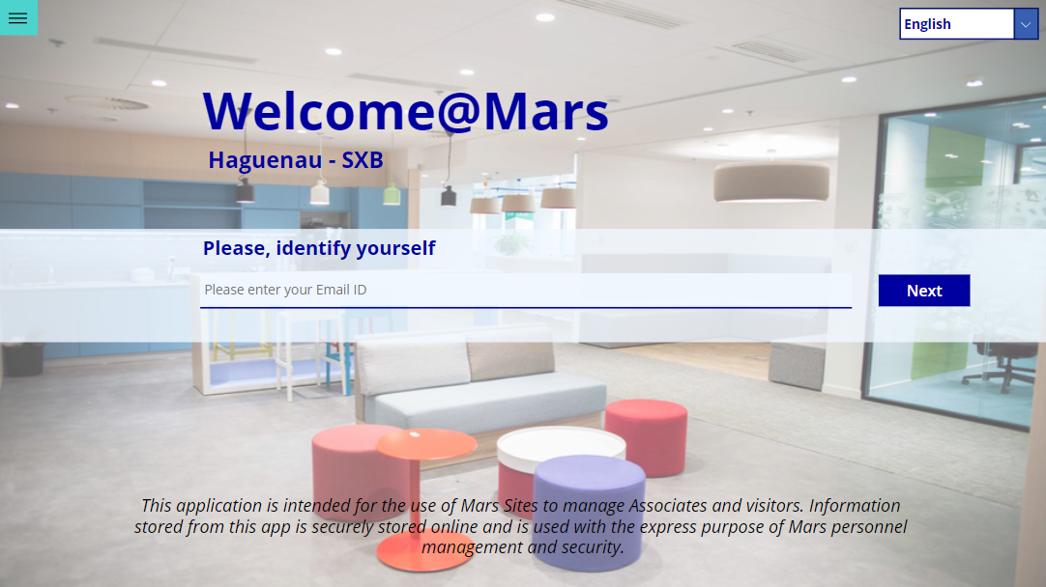

Visitor details will be fetched from Mars-AD for Associates and Contractors. External Visitors need to fill out their details here. All pre-registered visitors will have their basic details and host auto-populated as per pre-registration data.

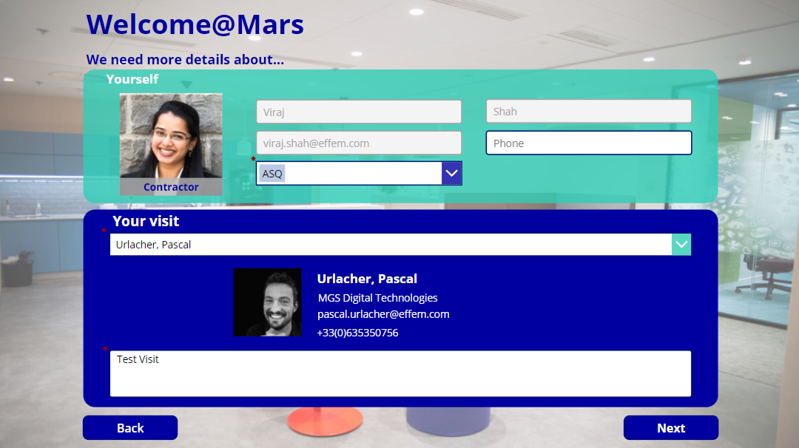

Host will be notified by Teams and Email once registration is completed for visitor.

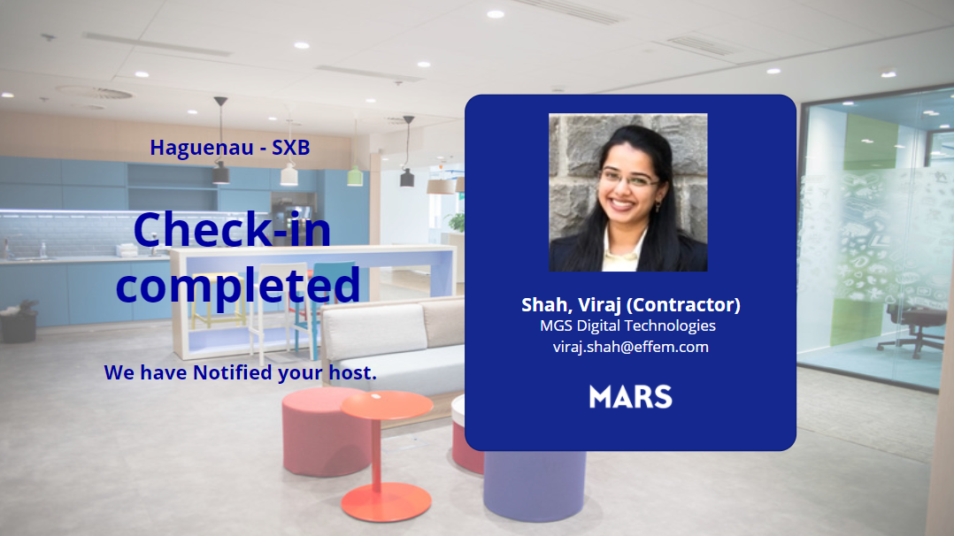

1. **Welcome@Mars Pre-Registration App**

Pre-Registration App will help hosts to pre-register their visitor’s visit well in advance to enable visitors with smooth and fast check-in process at the time of arrival at site. This application will be accessible to all Mars associates. Notification mail will be sent to each visitor with their visit and host details.

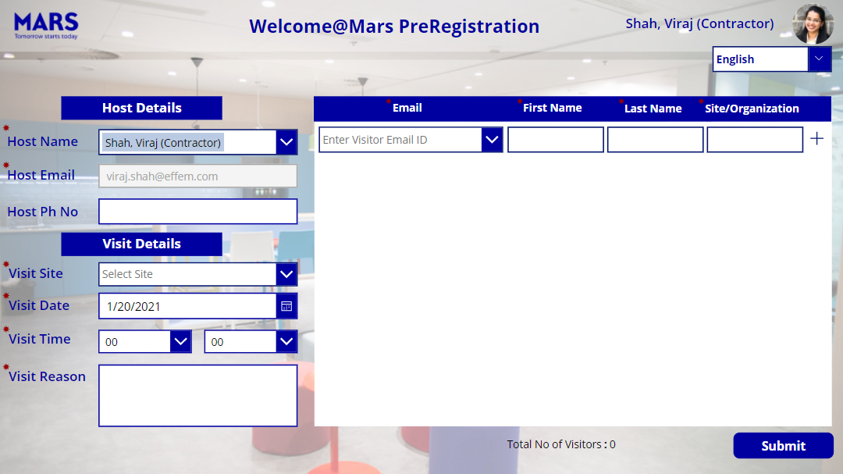

1. **Welcome@Mars Admin App**

Admin App will be place for Site Admin to manage site configurations, view registration and visitor details for the site and manually check-out visitors.

# Pre-Requisites

## Welcome@Mars Setup – System Requirements

To use the Welcome@Mars Registration App on your site, you will need to have:

1. A tablet (no preference) with a Front Camera
2. A good Wi-Fi connection with a generic Mars-AD account for the reception
3. A protection to ensure this tablet can’t be moved out of the reception

Welcome@Mars Pre-registration application will be accessible to all Mars associates. This application can be accessed using Laptop, Desktop via browser or Tablet.

Site Admin will have access to Welcome@Mars Admin application. They will be able to access this application using their Laptop or Desktop via browser.

## Welcome@Mars Cost

The implementation of this solution has a unique cost of 750$ per site. This cost is a one-time cost: it’s not annual – as such, you can use it several years for this unique cost.

Shall you request any additional feature, we can estimate the workload for it: shall you be OK with this estimation, you will have to fund this CIP but ALL sites will benefit from them.

## Power Apps License Requirements

At Mars, all users will have access to Power Apps with standard license. However, Welcome@Mars Registration and Admin applications will need Premium License to connect with its back-end – Common Data Services.

1. **Welcome@Mars Registration App –** 
   * As this application will be used for the site reception, we recommend you to install the application on a “generic” account used by your site reception.
   * You will need to request for “Power Apps Premium License” for this generic account. You can refer below link to understand process to get Premium License and follow the same –
   * <https://team.effem.com/sites/PowerApps/SitePages/Understand-Power-Apps-License-Management.aspx>
   * <https://mydrive.effem.com/:w:/r/personal/alexander_trotsko_effem_com/_layouts/15/guestaccess.aspx?e=hJMWaj&share=EQVXqfK7VeRHt9uZUGgVcxABv2rTyn57GZzDyabjzU9cDA>
2. **Welcome@Mars Pre-Registration App –** 
   * All Mars Associates and Contractors will have access to this application with Standard Power Apps License.
3. **Welcome@Mars Admin App –** 
   * Each site utilizing Welcome@Mars Apps will be mapped to one Site Admin.
   * This application is “Model-Driven” Power Apps application, which will need “Power Apps Premium License” for access. Designated Site Admin’s account must be configured with “Power Apps Premium License”.
   * If Site Admin is not assigned with Premium License, you will need to request for “Power Apps Premium License” for Site Admin’s account. You can refer below link to understand process to get Premium License and follow the same –
   * <https://team.effem.com/sites/PowerApps/SitePages/Understand-Power-Apps-License-Management.aspx>
   * <https://mydrive.effem.com/:w:/r/personal/alexander_trotsko_effem_com/_layouts/15/guestaccess.aspx?e=hJMWaj&share=EQVXqfK7VeRHt9uZUGgVcxABv2rTyn57GZzDyabjzU9cDA>

## Welcome@Mars Application Access

Once all the Power Apps License specific pre-requisites are completed, you can contact **Pascal Urlacher (pascal.urlacher@effem.com)** to get access to the Welcome@Mars Power Apps applications. You need to share generic account and Site Admin’s details with which application will be shared.

You can access Welcome@Mars applications using various devices -

1. **Welcome@Mars Registration Application –**

To access the Welcome@Mars Registration App, follow this procedure

* Download the Power Apps app on the Tablet – ensure you’re connected on your Tablet with your site’s “Generic Microsoft-AD Account”.
* Click on the Power Apps icon now available on your Tablet.
* You should be able to see all apps you have access to – click on the Welcome@Mars Registration icon to launch the App.
* Select your site from the first screen (Select Our Site) and then setup Camera (Front / Back) as per device configuration from subsequent screen.

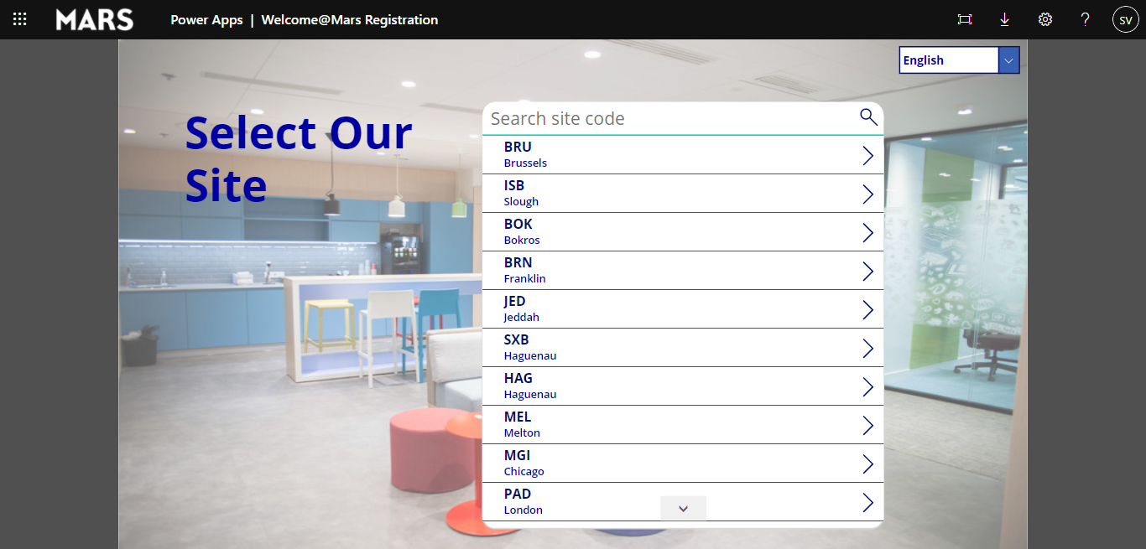

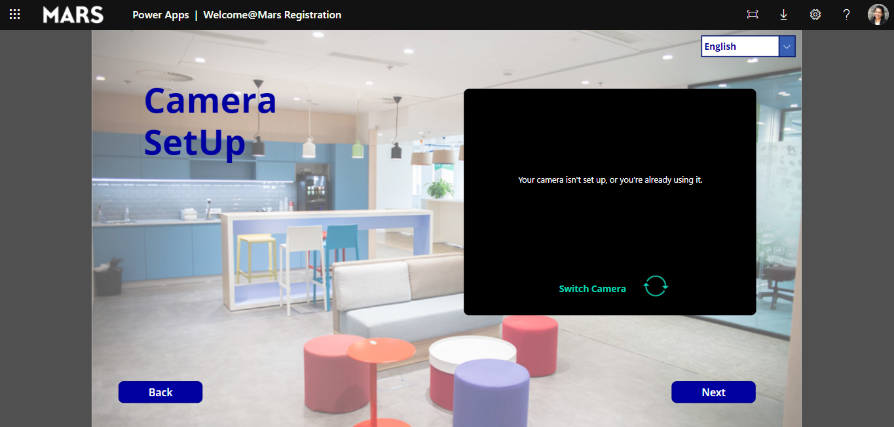

1. **Welcome@Mars Pre-Registration Application –**

To access the Welcome@Mars Pre-Registration App, follow this procedure

* **Using a Computer -**
  + You can access Power Apps by using the link https://make.powerapps.com/
  + Change the Power Apps environment to “DigitalExperience Prod” from top right of the screen.

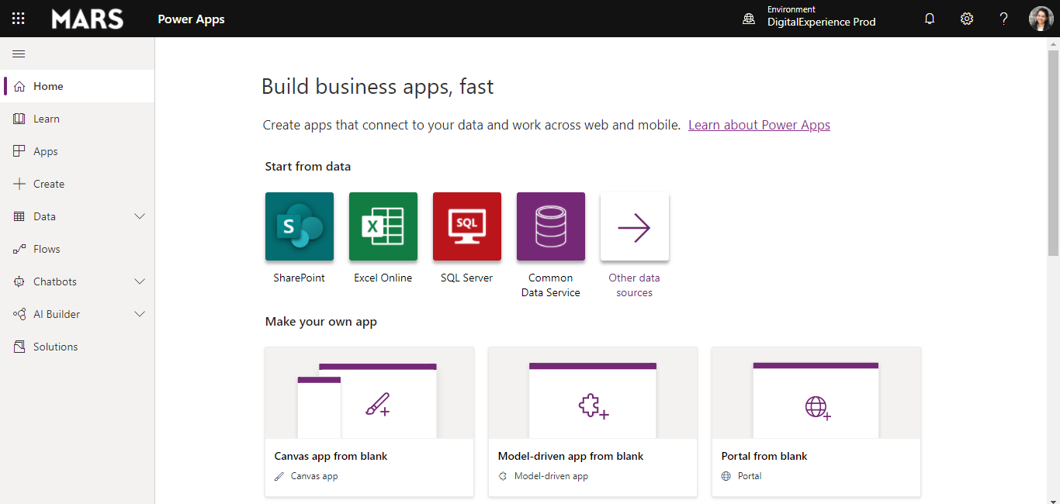

* + Once connected you should see the list of applications you have access to (or developed yourself). Click on “Welcome@Mars PreRegistration” to access the app.

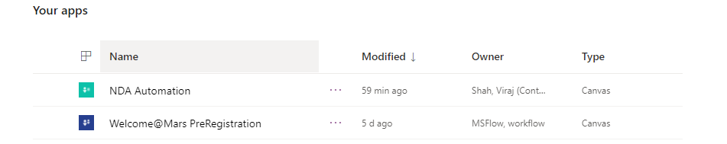

* + You should also be able to access the app by clicking on this link –

[Welcome@Mars PreRegistration](https://apps.powerapps.com/play/e9f3a5c6-587b-43ee-93ab-9f1908b53202?tenantId=2fc13e34-f03f-498b-982a-7cb446e25bc6)

* **Using a Tablet -**
  + To access the Welcome@Mars Pre-Registration App from your Tablet, follow similar steps as Registration application.
  + Ensure you’re connected on your Tablet with your “Microsoft-AD Account” to access Pre-Registration application.

1. **Welcome@Mars Admin Application –**

To access the Welcome@Mars Admin App, follow this procedure

* **Using a Computer -**
  + You can access Power Apps by using the link https://make.powerapps.com/. Ensure Site Admin is connected with his “Microsoft-AD Account” to access Admin application.
  + Change the Power Apps environment to “DigitalExperience Prod” from top right of the screen.
  + Once connected you should see the list of applications you have access to (or developed yourself). Click on “Welcome@Mars Admin” to access the app.

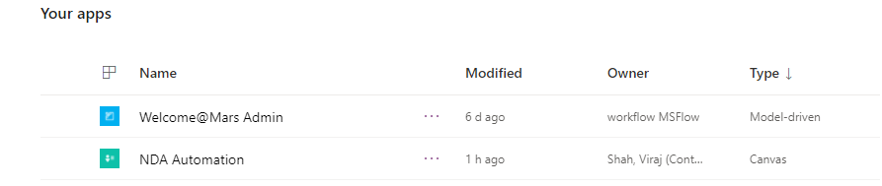

* + You should also be able to access the app by clicking on this link –

[Welcome@Mars Admin](https://orge0f7357d.crm.dynamics.com/main.aspx?appid=c221dd2a-36f9-4a7d-9d20-b07a497c0c28)

* **Using a Tablet -**
  + To access the Welcome@Mars Admin App from your Tablet, follow similar steps as Registration application.
  + Ensure Site Admin is connected with his “Microsoft-AD Account” to access Admin application.

# Welcome@Mars Functionalities

Here is the list of existing / upcoming functionalities of Welcome@Mars applications –

|  |  |
| --- | --- |
| **Existing**   * Enables the management of visitors (Associates, Contractors & External Visitors) for check-in & check-out * Available in several languages (English & French languages are configured so far. if more required, please contact Pascal Urlacher) * Integrated the Microsoft-AD & O365 Profile for Associates & Contractors * Visitor Pre-registration to proceed to a quick check-in * Pre-Registration app accessible to all Mars Associates without any extra license requirement * Notification Emails to Pre-Registered visitors with Visit and Host details * Easy and fast check-in for pre-registered users with auto-population of their visit details * Configurable time-frame to complete the check-in process * Mandatory Non-Disclosure Agreement for all visitors to complete the check-in * Sends a notification to the host by Teams & Mail using MS Flow * Data stored in CDS – Common Data Services (GDPR compliant) * Site Specific Configurations through Admin App * Registration & Visitor Data Management via Admin App | **Upcoming / Feasibility Study**   * Auto Check-Out option for each visitor at the end of the day and notification by mail (to visitor & host) * Site Specific Configurable message to all visitors at a time of pre-registration |

Shall be interested by this application, please contact **Pascal Urlacher**.